Database Creation
CREATE DATABASE DBMS_Practical;
Select the Database
USE DBMS_Practical;
Create COURSE Table
CREATE TABLE COURSE (
Course_ID INT PRIMARY KEY,
Course_Name VARCHAR(50),
Fees DECIMAL(10,2)
);
Create STUDENT Table
CREATE TABLE STUDENT (
Student_ID INT PRIMARY KEY,
Student_Name VARCHAR(50),
Course_ID INT,
Marks INT
);
INSERT
INSERT INTO COURSE VALUES
(101, 'Data Science', 50000),
(102, 'Computer Science', 45000),
(103, 'Information Technology', 40000),
(104, 'Artificial Intelligence', 55000);
SELECT * FROM COURSE;

INSERT INTO STUDENT VALUES
(1, 'Aarav', 101, 85),
(2, 'Sneha', 102, 72),
(3, 'Rahul', 101, 65),
(4, 'Priya', 103, 90),
(5, 'Rohan', 102, 60),
(6, 'Ananya', 104, 78),
(7, 'Neha', 101, 75),
(8, 'Aditya', 103, 55);
SELECT * FROM STUDENT;
Q1)b)Display students who have scored more than 70 marks.
SELECT *
FROM STUDENT
WHERE Marks > 70;
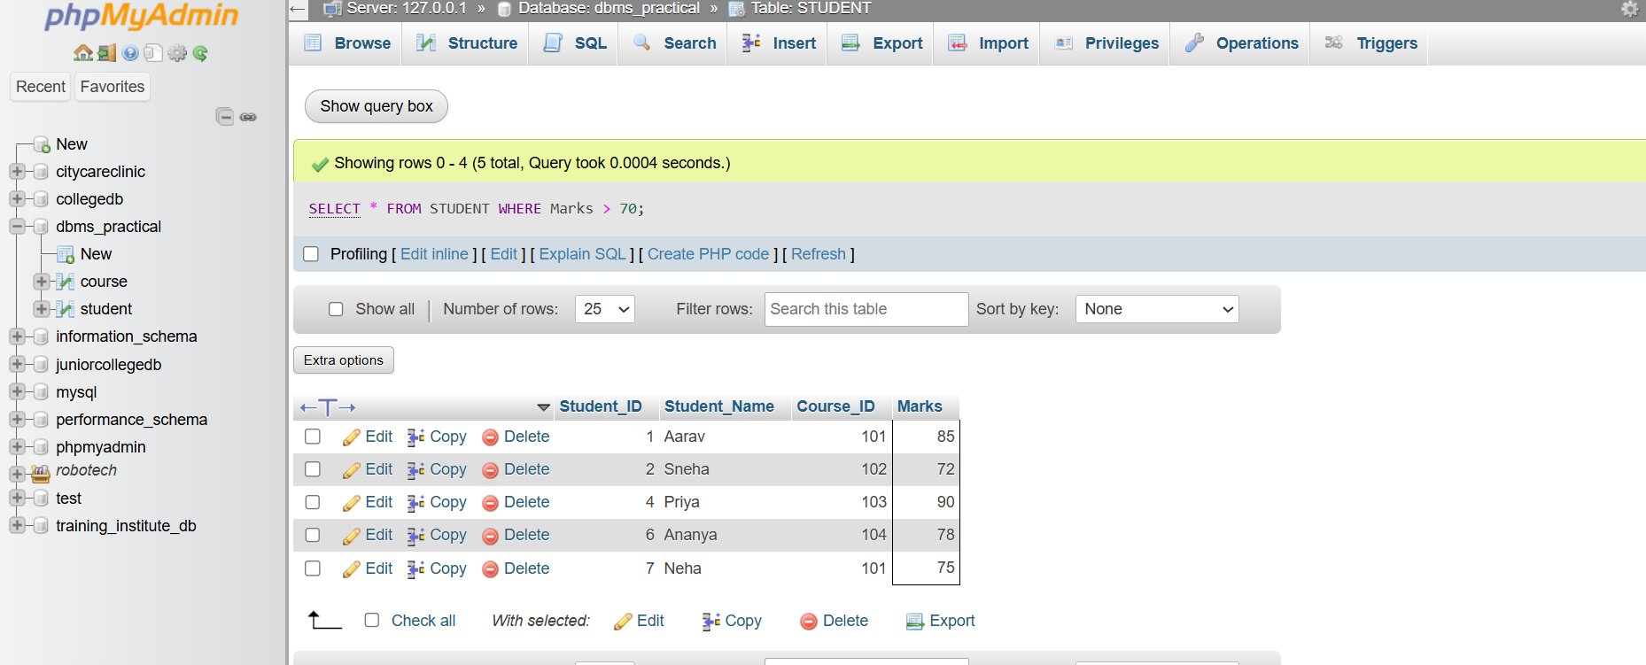

Q1(c): Display student names with their course names
SELECT s.Student_Name, c.Course_Name
FROM STUDENT s
JOIN COURSE c
ON s.Course_ID = c.Course_ID;
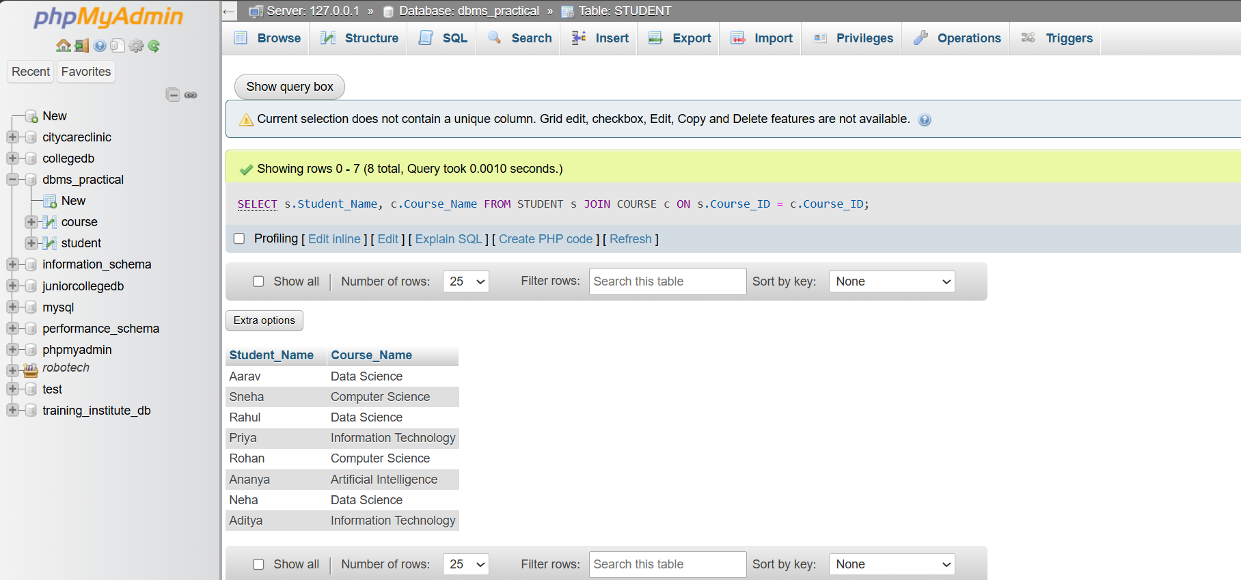
Q1(d): Find average marks for each Course_ID
SELECT Course_ID, AVG(Marks) AS Average_Marks
FROM STUDENT
GROUP BY Course_ID;
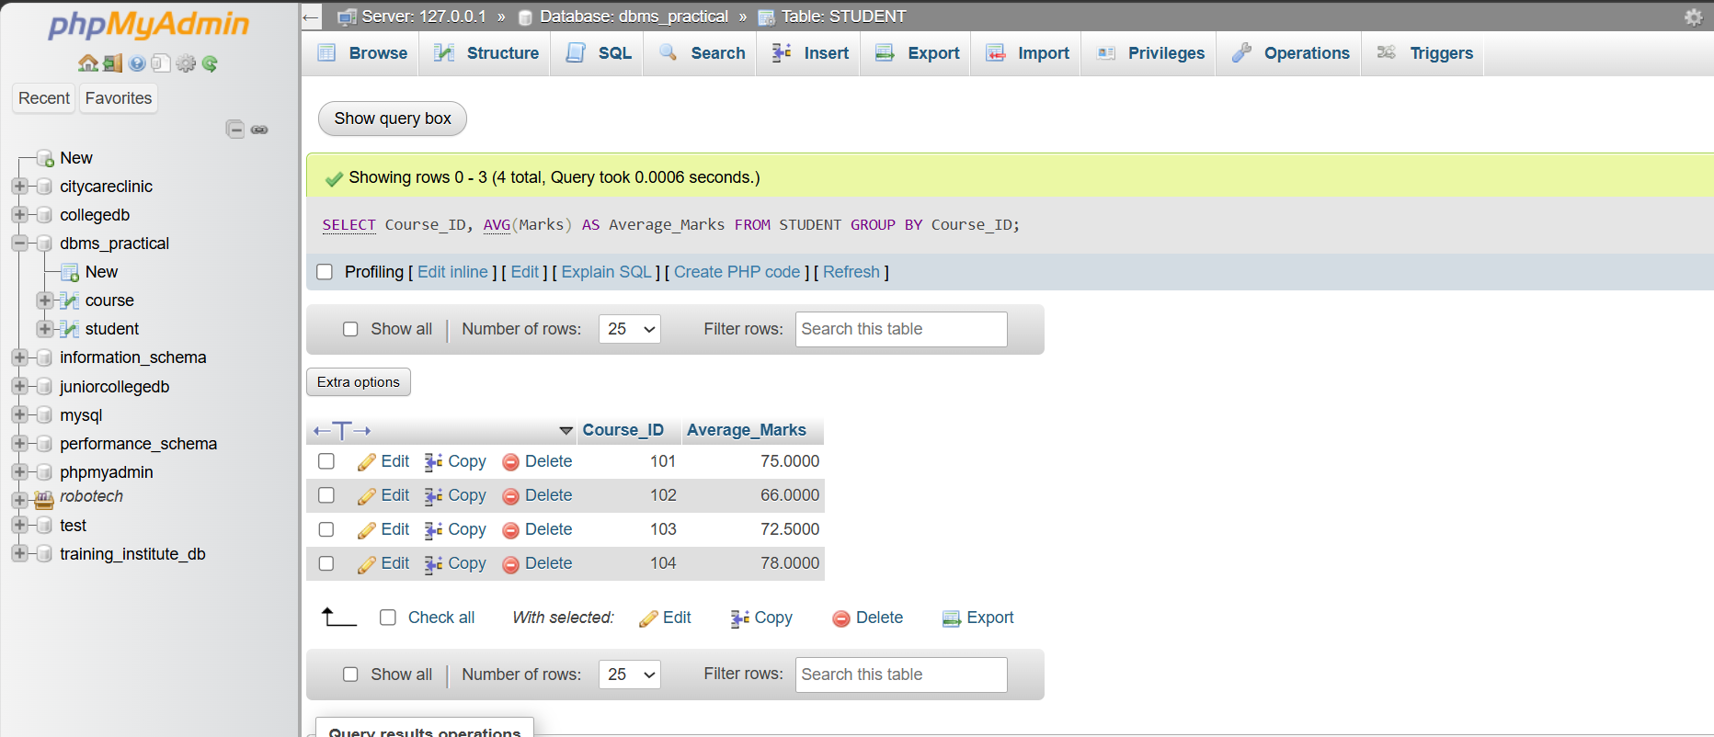
Q1)E)Display only those courses whose average marks are greater than 65 using HAVING.

SELECT Course_ID, AVG(Marks) AS Average_Marks
FROM STUDENT
GROUP BY Course_ID
HAVING AVG(Marks) > 65;
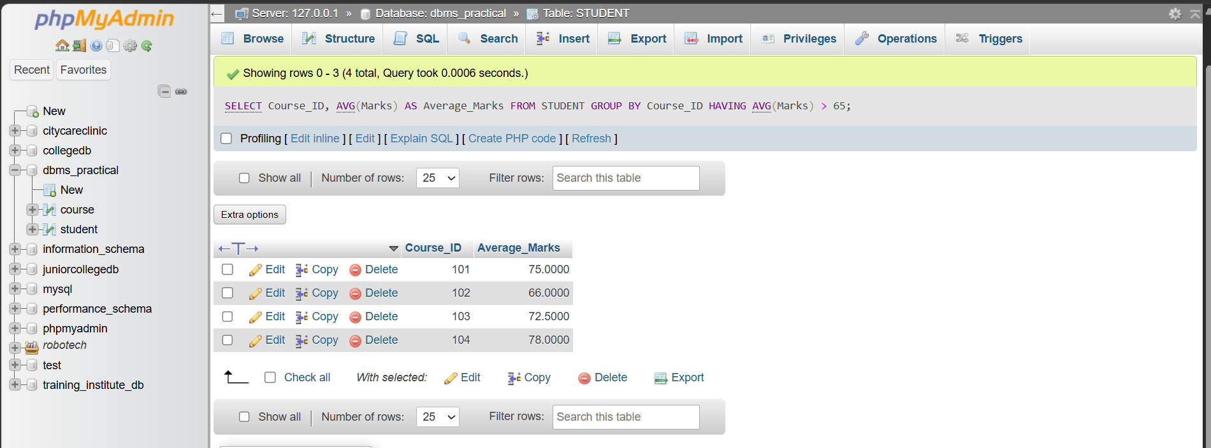
Q2: Create EMPLOYEE table
CREATE TABLE EMPLOYEE (
Emp_ID INT PRIMARY KEY,
Emp_Name VARCHAR(50),
Department VARCHAR(50),
Salary DECIMAL(10,2),
Joining_Date DATE
);
DESC EMPLOYEE;
INSERT INTO EMPLOYEE VALUES
(1, 'Amit', 'IT', 60000, '2024-01-15'),
(2, 'Neha', 'HR', 45000, '2023-06-20'),
(3, 'Rahul', 'IT', 75000, '2022-03-10'),
(4, 'Priya', 'Finance', 55000, '2024-02-05'),
(5, 'Sneha', 'IT', 65000, '2023-08-12'),
(6, 'Rohan', 'HR', 40000, '2025-01-18'),
(7, 'Ananya', 'IT', 80000, '2022-11-25'),
(8, 'Karan', 'Finance', 60000, '2023-04-14'),
(9, 'Pooja', 'IT', 70000, '2024-07-09'),
(10, 'Vikas', 'Sales', 50000, '2023-09-30');
SELECT * FROM EMPLOYEE;
Q2)A)Display employees belonging to the IT department in descending order of salary.
SELECT *
FROM EMPLOYEE
WHERE Department = 'IT'
ORDER BY Salary DESC;
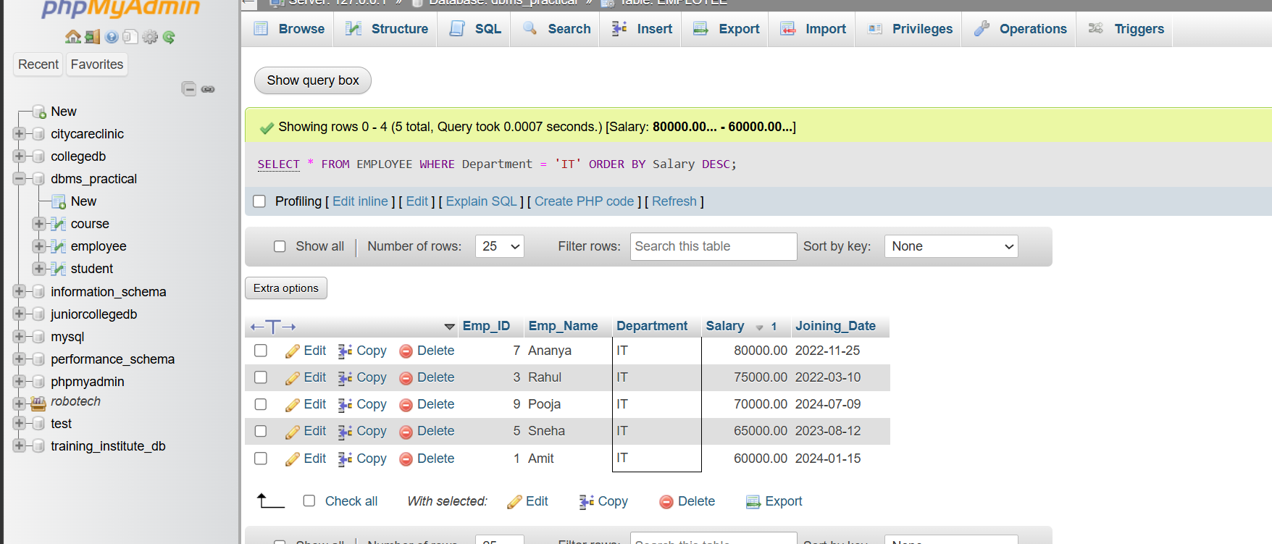
Q2(b): Find the highest salary
SELECT MAX(Salary) AS Highest_Salary
FROM EMPLOYEE;
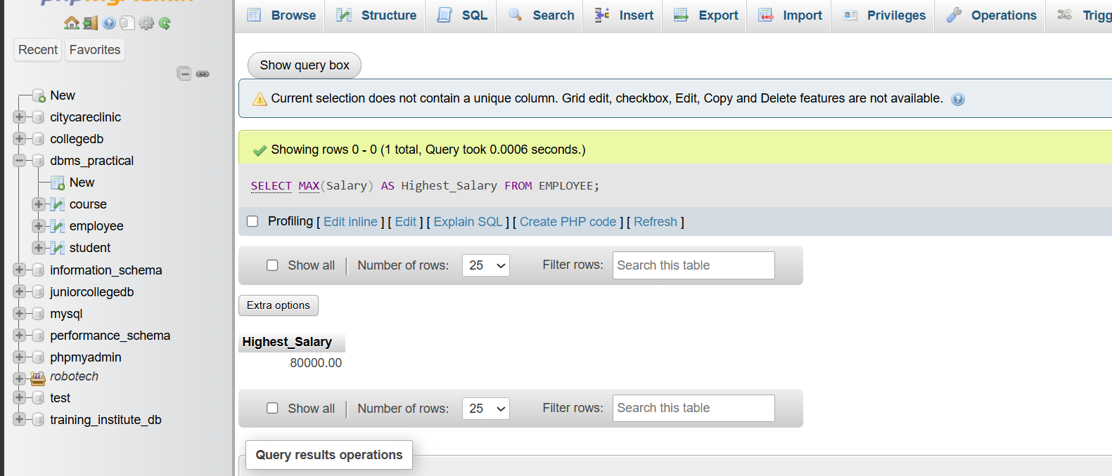
Q2(c): Departments having more than 3 employees
SELECT Department, COUNT(*) AS Employee_Count
FROM EMPLOYEE
GROUP BY Department
HAVING COUNT(*) > 3;
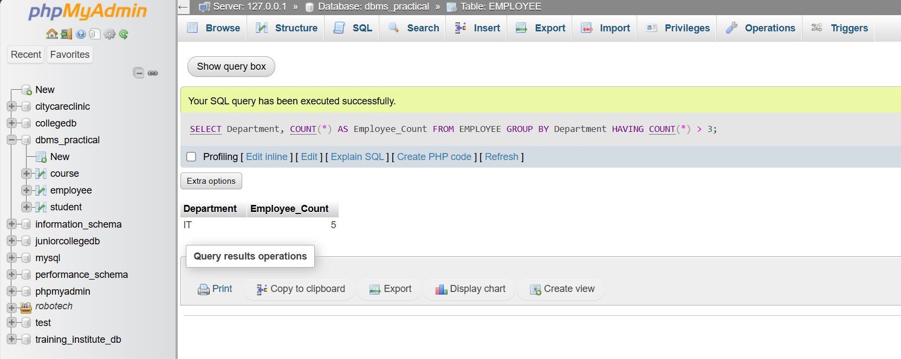
Q2(d): Employees earning more than the average salary
SELECT *
FROM EMPLOYEE
WHERE Salary > (
SELECT AVG(Salary)
FROM EMPLOYEE
);
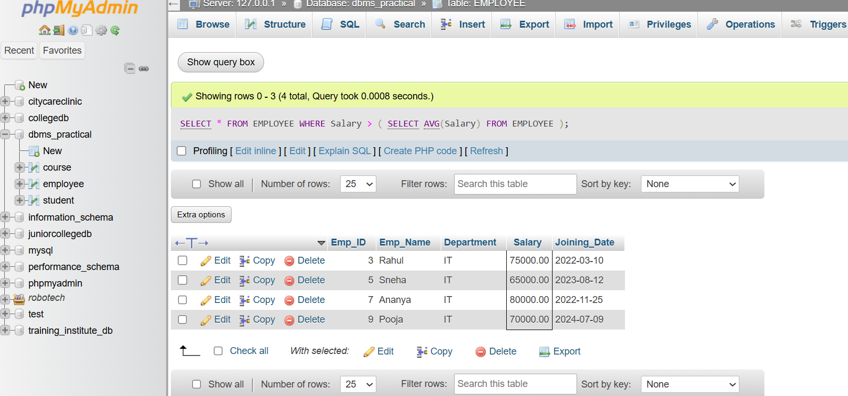
Q2(e): Create a VIEW
CREATE VIEW IT_Employees AS
SELECT *
FROM EMPLOYEE
WHERE Department = 'IT';
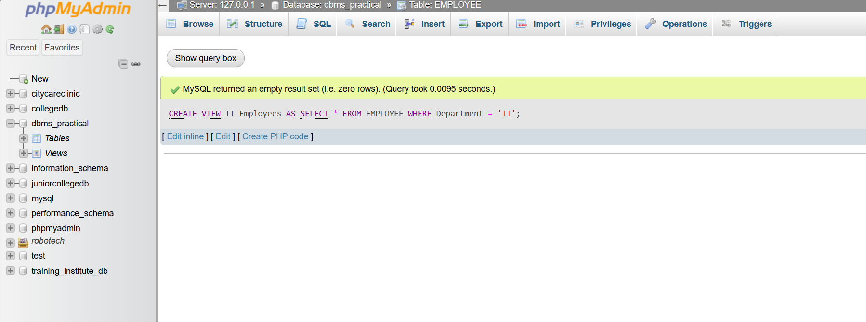
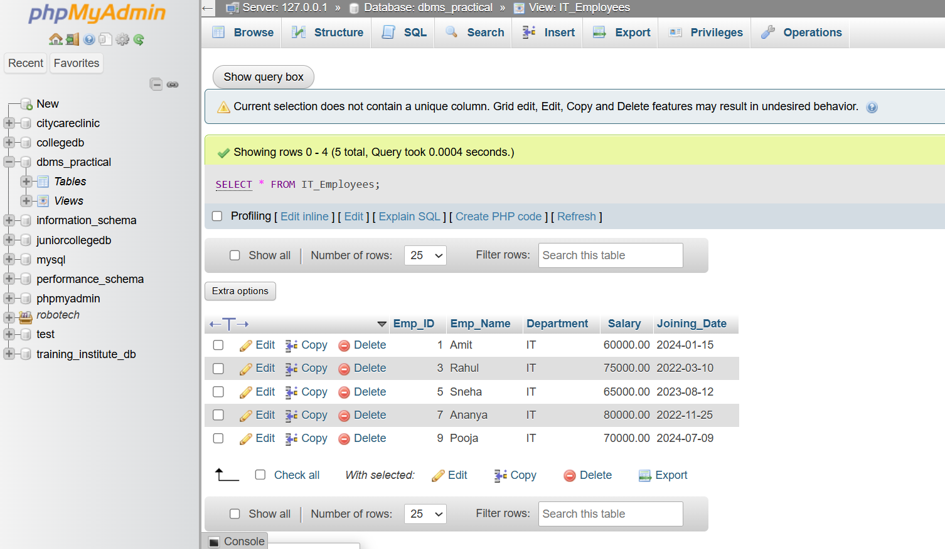
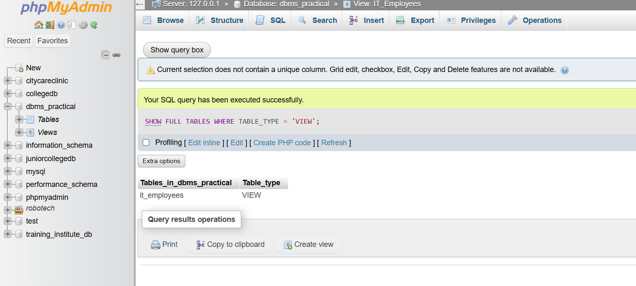

Final summary of the questions
-- Q1(a)
CREATE TABLE STUDENT (
Student_ID INT PRIMARY KEY,
Student_Name VARCHAR(50),
Course_ID INT,
Marks INT
);

-- Q1(b)
SELECT *
FROM STUDENT
WHERE Marks > 70;

-- Q1(c)
SELECT s.Student_Name, c.Course_Name
FROM STUDENT s
JOIN COURSE c
ON s.Course_ID = c.Course_ID;

-- Q1(d)
SELECT Course_ID, AVG(Marks) AS Average_Marks
FROM STUDENT
GROUP BY Course_ID;

-- Q1(e)
SELECT Course_ID, AVG(Marks) AS Average_Marks
FROM STUDENT
GROUP BY Course_ID
HAVING AVG(Marks) > 65;

Q2 — EMPLOYEE
-- Q2(a)
SELECT *
FROM EMPLOYEE
WHERE Department = 'IT'
ORDER BY Salary DESC;

-- Q2(b)
SELECT MAX(Salary) AS Highest_Salary
FROM EMPLOYEE;

-- Q2(c)
SELECT Department, COUNT(*) AS Employee_Count
FROM EMPLOYEE
GROUP BY Department
HAVING COUNT(*) > 3;

